Project Safecracker Playbook

I. Challenge
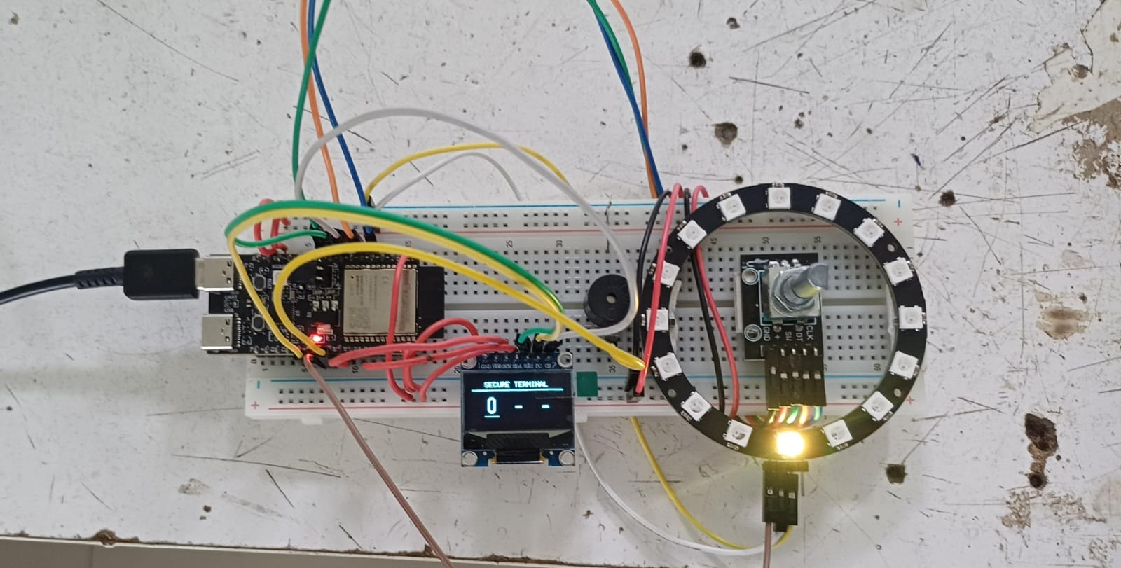
Develop a digital combination lock vault interface that merges physical rotational inputs with multi-tiered security authentication layers. The system must evaluate phase-shifted quadrature signals via interrupt service routines (ISRs), implement bitwise state-tracking to eliminate mechanical contact bounce, drive a 1:1 hardware-mapped RGB LED ring, manage a multi-mode finite state machine (LOCKED, SUCCESS, ALARM), and render real-time UI feedback on an SPI-driven OLED display.

II. Guide

A. Concept

i. Underlying Engineering Principles & Reference Links
- Quadrature Decoding & Phase Shifts: Quadrature rotary encoders output square waves across two channel pins ($\text{Channel A}$ and $\text{Channel B}$). Rotating the shaft produces a ${90}^{∘}$ phase shift between channels, yielding a binary gray-code sequence ($00→01→11→10$). Evaluating which channel leads determines rotation direction.
  - Learn More: Introduction to Rotary Encoders
- ISR Bitwise State-Tracking (Hardware Debouncing): Mechanical switch contacts inside rotary encoders suffer from bounce noise spikes. Instead of using blocking delay() functions, an Interrupt Service Routine (ISR) shifts previous and current 2-bit channel states into a 4-bit nibble (movementState). The counter increments or decrements only when valid physical state sequences are matched, filtering out noise.
  - Learn More: Interrupt Service Routines Best Practices
- Finite State Machines (FSM) in Security Architecture: Multi-mode security systems rely on rigid operational states (LOCKED, SUCCESS, ALARM). Transition conditions evaluate user input strings against a hardcoded passcode array (PASSCODE[3]), incrementing failure counters or shifting to lockout modes upon reaching limit thresholds.
  - Learn More: Finite State Machines
- 1:1 Hardware-to-Visual Index Mapping: Mapping physical rotational encoder positions ($0-15$) directly to physical indexes on a 16-element addressable LED ring provides instantaneous visual positioning feedback to the operator.
  - Learn More: Adafruit – NeoPixel Driver Math & Index Mapping

ii. Real-World Example
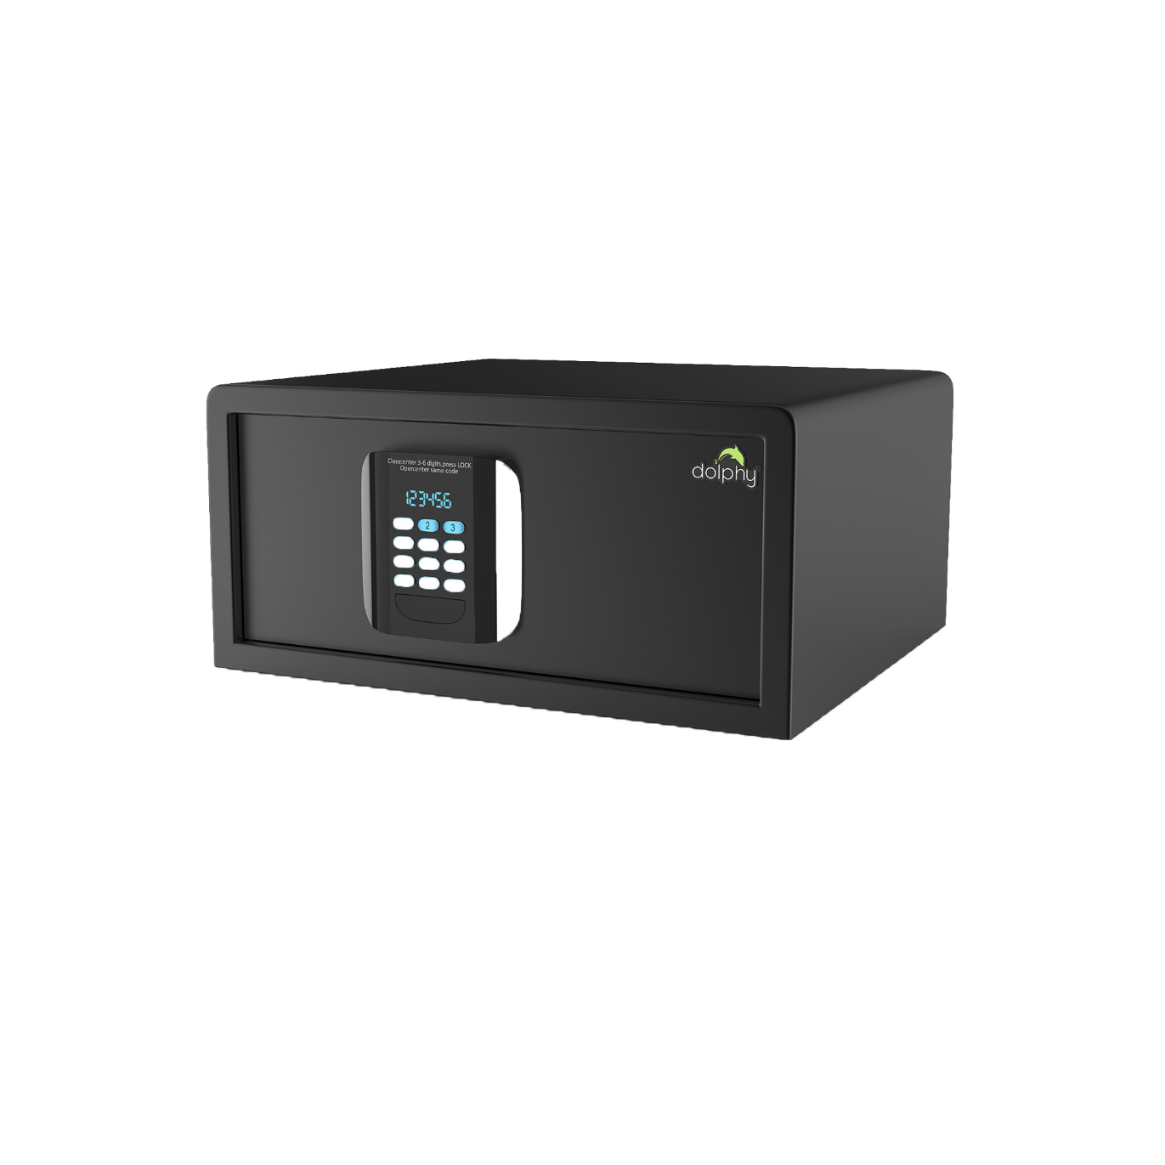
Commercial bank vault combination dials, digital safe keypads, industrial rotary selector switches, and automotive infotainment control knobs (e.g., BMW iDrive or Audi MMI systems). These applications rely on quadrature encoding and FSM security logic for tactile user interaction.

B. Components
- Microcontroller: Espressif ESP32-C6-DevKitC-1 (32-bit RISC-V SoC)
- Input Peripheral: Quadrature Rotary Encoder (with integrated push-button switch)
- Visual Peripherals: 16-LED RGB Ring Module (WS2812B) & 0.96-inch SPI OLED Display (SSD1306 driver)
- Audio Transducer: Active Buzzer Module
- Interconnect Base: Solderless breadboard and jumper wires

C. Connections
Module Pin | ESP32-C6 DevKit Pin | Signal Type | Power Domain / Function Description
Encoder CLK | GPIO 6 | Interrupt (Phase A) | 3V3 Logic Input
Encoder DT | GPIO 7 | Input (Phase B) | 3V3 Logic Input
Encoder SW | GPIO 10 | Input (Button) | 3V3 Logic Input (Internal Pull-Up)
Encoder VCC | 3.3V | Logic Power | 3V3 Logic Power Rail
OLED SCK | GPIO 21 | SPI Clock | 3V3 Logic Output
OLED MOSI | GPIO 22 | SPI Data | 3V3 Logic Output
OLED RES | GPIO 8 | Reset Flag | 3V3 Logic Output
OLED DC | GPIO 9 | Data/Command | 3V3 Logic Output
OLED CS | GPIO 1 | Chip Select | 3V3 Logic Output
OLED VCC | 3.3V | Logic Power | 3V3 Logic Power Rail
RGB Ring DI | GPIO 18 | High-Speed Data | 5V High-Current Domain Signal
RGB Ring VCC | 5V / VBUS | Direct Power | 5V High-Current Rail (Direct USB)
Buzzer I/O | GPIO 19 | Digital Trigger | 3V3 Logic Output (Active HIGH)
GND (All) | GND | Common Reference | System Ground Plane

D. Code
1. C++
2. #include <Arduino.h>
3. #include <Wire.h>
4. #include <SPI.h>
5. #include <U8g2lib.h>
6. #include <Adafruit_NeoPixel.h>
7.
8. // --- Pin Definitions ---
9. #define SPI_OLED_SCK 21
10. #define SPI_OLED_SDA 22
11. #define SPI_OLED_CS 1
12. #define SPI_OLED_RES 8
13. #define SPI_OLED_DC 9
14.
15. #define ENCODER_CLK 6
16. #define ENCODER_DT 7
17. #define ENCODER_SW 10
18.
19. #define LED_RING_PIN 18
20. #define BUZZER_PIN 19
21. #define NUM_LEDS 16
22.
23. // --- Object Initialization ---
24. U8G2_SSD1306_128X64_NONAME_F_4W_HW_SPI oled(U8G2_R0, SPI_OLED_CS, SPI_OLED_DC, SPI_OLED_RES);
25. Adafruit_NeoPixel ring(NUM_LEDS, LED_RING_PIN, NEO_GRB + NEO_KHZ800);
26.
27. // --- Security State Machine ---
28. enum SystemState { LOCKED, SUCCESS, ALARM };
29. SystemState currentState = LOCKED;
30.
31. const int PASSCODE[3] = {9, 1, 15};
32. int userInput[3] = {0, 0, 0};
33. int currentDigitIndex = 0;
34. int failedAttempts = 0;
35.
36. // --- Volatile Encoder Tracking ---
37. volatile int encoderValue = 0;
38. volatile uint8_t previousPhase = 0;
39. int lastEncoderValue = 0;
40.
41. // --- Advanced State-Tracking Interrupt (Bounce-Proof) ---
42. void IRAM_ATTR readEncoder() {
43. uint8_t currentA = digitalRead(ENCODER_CLK);
44. uint8_t currentB = digitalRead(ENCODER_DT);
45.
46. uint8_t currentPhase = (currentA << 1) | currentB;
47. uint8_t movementState = (previousPhase << 2) | currentPhase;
48.
49. // Exact clockwise physical sequence
50. if (movementState == 0b1101 || movementState == 0b0100 || movementState == 0b0010 || movementState == 0b1011) {
51. encoderValue++;
52. if (encoderValue > 15) encoderValue = 0;
53. }
54. // Exact counter-clockwise physical sequence
55. else if (movementState == 0b1110 || movementState == 0b0111 || movementState == 0b0001 || movementState == 0b1000) {
56. encoderValue--;
57. if (encoderValue < 0) encoderValue = 15;
58. }
59.
60. previousPhase = currentPhase;
61. }
62.
63. // --- Helper Functions ---
64. void setRingColor(uint8_t r, uint8_t g, uint8_t b) {
65. for(int i = 0; i < NUM_LEDS; i++) {
66. ring.setPixelColor(i, ring.Color(r, g, b));
67. }
68. ring.show();
69. }
70.
71. void soundChirp() {
72. digitalWrite(BUZZER_PIN, HIGH);
73. delay(40);
74. digitalWrite(BUZZER_PIN, LOW);
75. }
76.
77. void setup() {
78. Serial.begin(115200);
79.
80. pinMode(BUZZER_PIN, OUTPUT);
81. pinMode(ENCODER_SW, INPUT_PULLUP);
82. pinMode(ENCODER_CLK, INPUT_PULLUP);
83. pinMode(ENCODER_DT, INPUT_PULLUP);
84.
85. attachInterrupt(digitalPinToInterrupt(ENCODER_CLK), readEncoder, CHANGE);
86. attachInterrupt(digitalPinToInterrupt(ENCODER_DT), readEncoder, CHANGE);
87.
88. SPI.begin(SPI_OLED_SCK, -1, SPI_OLED_SDA, SPI_OLED_CS);
89. oled.begin();
90.
91. ring.begin();
92. ring.setBrightness(40);
93. setRingColor(0, 0, 0);
94. }
95.
96. void loop() {
97. unsigned long currentMillis = millis();
98.
99. switch (currentState) {
100.
101. case LOCKED: {
102. userInput[currentDigitIndex] = encoderValue;
103.
104. // Visual feedback: Direct 1:1 hardware mapping
105. ring.clear();
106. ring.setPixelColor(encoderValue, ring.Color(255, 200, 0));
107. ring.show();
108.
109. // Audio feedback
110. if (encoderValue != lastEncoderValue) {
111. soundChirp();
112. lastEncoderValue = encoderValue;
113. }
114.
115. // Input Confirmation (Switch Pressed)
116. if (digitalRead(ENCODER_SW) == LOW) {
117. delay(50);
118. while(digitalRead(ENCODER_SW) == LOW);
119.
120. soundChirp(); delay(50); soundChirp();
121.
122. currentDigitIndex++;
123. encoderValue = 0;
124.
125. // Verification phase
126. if (currentDigitIndex >= 3) {
127. if (userInput[0] == PASSCODE[0] && userInput[1] == PASSCODE[1] && userInput[2] == PASSCODE[2]) {
128. currentState = SUCCESS;
129. } else {
130. failedAttempts++;
131. setRingColor(255, 0, 0);
132. digitalWrite(BUZZER_PIN, HIGH);
133. delay(500);
134. digitalWrite(BUZZER_PIN, LOW);
135.
136. if (failedAttempts >= 3) {
137. currentState = ALARM;
138. } else {
139. currentDigitIndex = 0;
140. setRingColor(0, 0, 0);
141. }
142. }
143. }
144. }
145.
146. // Render UI Dashboard
147. oled.clearBuffer();
148. oled.setFont(u8g2_font_6x10_tf);
149. oled.setCursor(18, 12); oled.print("SECURE TERMINAL");
150. oled.drawHLine(0, 16, 128);
151.
152. oled.setFont(u8g2_font_logisoso22_tr);
153.
154. // Slot 1
155. if (currentDigitIndex > 0) oled.drawStr(20, 48, "*");
156. else if (currentDigitIndex == 0) { oled.setCursor(20, 48); oled.print(userInput[0]); }
157. else oled.drawStr(20, 48, "-");
158.
159. // Slot 2
160. if (currentDigitIndex > 1) oled.drawStr(58, 48, "*");
161. else if (currentDigitIndex == 1) { oled.setCursor(58, 48); oled.print(userInput[1]); }
162. else oled.drawStr(58, 48, "-");
163.
164. // Slot 3
165. if (currentDigitIndex > 2) oled.drawStr(96, 48, "*");
166. else if (currentDigitIndex == 2) { oled.setCursor(96, 48); oled.print(userInput[2]); }
167. else oled.drawStr(96, 48, "-");
168.
169. // Draw selector underline
170. if (currentDigitIndex == 0) oled.drawHLine(18, 52, 20);
171. if (currentDigitIndex == 1) oled.drawHLine(56, 52, 20);
172. if (currentDigitIndex == 2) oled.drawHLine(94, 52, 20);
173.
174. oled.sendBuffer();
175.
176. // Diagnostic Telemetry Stream
177. Serial.print("State:"); Serial.print(currentState); Serial.print(",");
178. Serial.print("Encoder:"); Serial.print(encoderValue); Serial.print(",");
179. Serial.print("Slot:"); Serial.print(currentDigitIndex); Serial.print(",");
180. Serial.print("Failures:"); Serial.println(failedAttempts);
181. break;
182. }
183.
184. case SUCCESS: {
185. setRingColor(0, 255, 0);
186.
187. oled.clearBuffer();
188. oled.setFont(u8g2_font_9x15B_tf);
189. oled.setCursor(22, 38);
190. oled.print("UNLOCKED");
191. oled.sendBuffer();
192.
193. Serial.print("State:"); Serial.println("SUCCESS_UNLOCKED");
194. break;
195. }
196.
197. case ALARM: {
198. if ((currentMillis / 200) % 2 == 0) {
199. setRingColor(255, 0, 0);
200. digitalWrite(BUZZER_PIN, HIGH);
201. } else {
202. setRingColor(0, 0, 0);
203. digitalWrite(BUZZER_PIN, LOW);
204. }
205.
206. oled.clearBuffer();
207. oled.setFont(u8g2_font_9x15B_tf);
208. oled.setCursor(30, 38);
209. oled.print("LOCKDOWN");
210. oled.sendBuffer();
211.
212. Serial.print("State:"); Serial.println("ALARM_LOCKDOWN");
213. break;
214. }
215. }
216. }
217.

Student Tip: Open the Serial Monitor (Ctrl+Shift+M) at 115200 baud to trace state changes, track live encoder values, and monitor failed authentication attempts.
To inspect encoder positioning stability, open the Serial Plotter (Ctrl+Shift+L). Plotting Encoder against Slot and Failures lets you visually verify that bitwise ISR debouncing eliminates spurious counter jumps during rapid dial rotations.

III. Play & Share
- Dynamic Passcode Generation / Master Key Reset: Add a feature where holding the rotary encoder button down for 3 seconds while in the SUCCESS state prompts the user to dial in and save a brand-new 3-digit combination stored in non-volatile storage (Preferences.h).
- Time-Based Duress Lockout Expire: Modify the ALARM state using millis() so that instead of requiring a hard system power reboot, the vault undergoes a strict 60-second lockout penalty timer shown on the OLED screen before resetting back to LOCKED.
- Tactile Haptic Click Synthesis: Upgrade the active buzzer to a passive piezo transducer driven by ledcWrite(). Synthesize pitch clicks ($1500\text{ Hz}$ tone for $10\text{ ms}$) on encoder steps, and play distinct rising or falling musical arpeggios for successful entries or lockouts!

